|  |  |
| --- | --- |
| Name | Kailash S |
| Date | 10-01-24 |
| Assn.no | 3 |
| Topic | Dev ops Pipeline |

DevOps Assignment

Creating Azure YAML Pipeline:

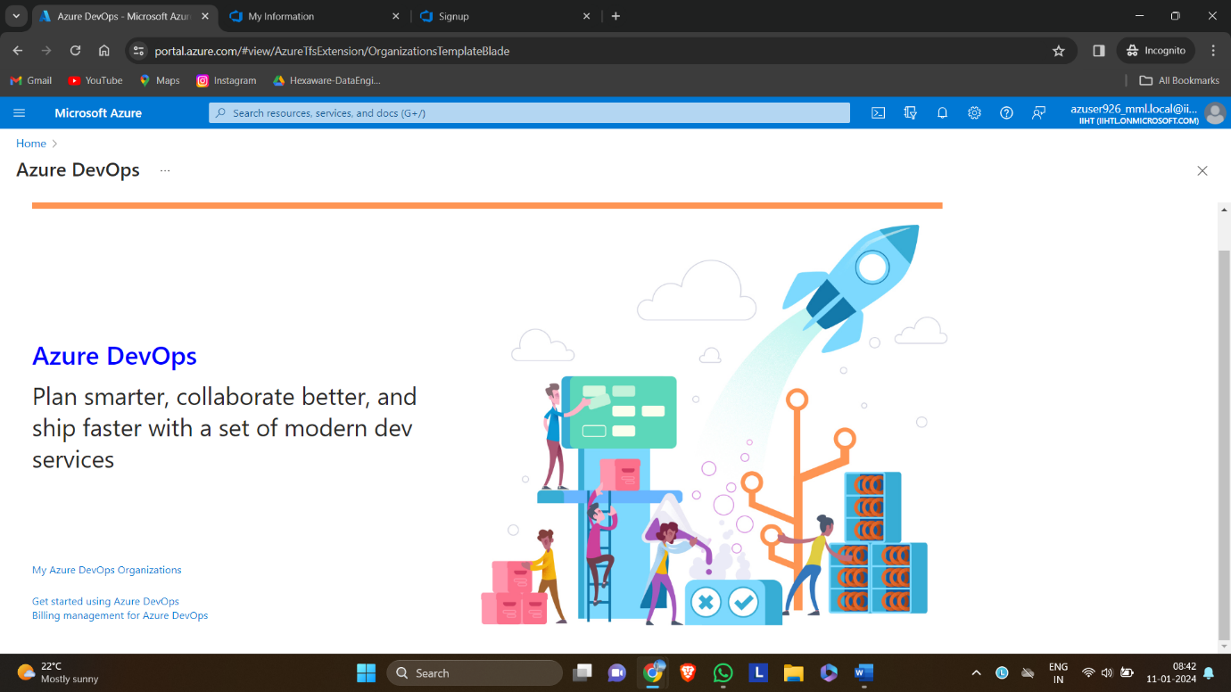

Create azure organization

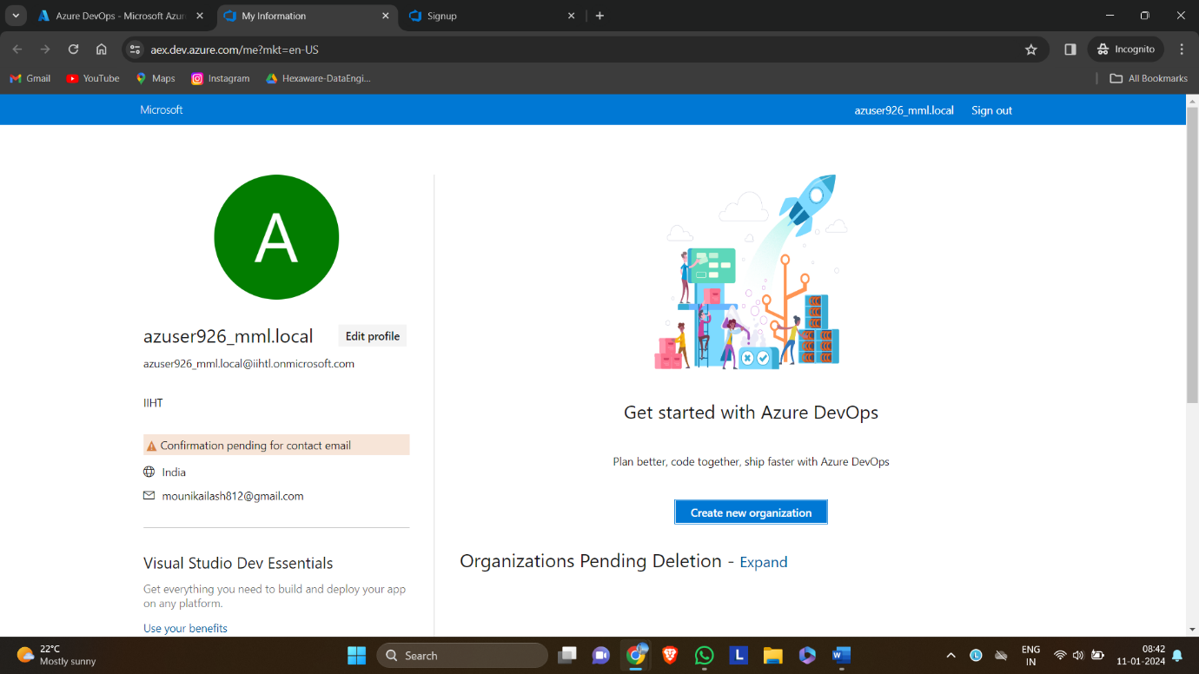

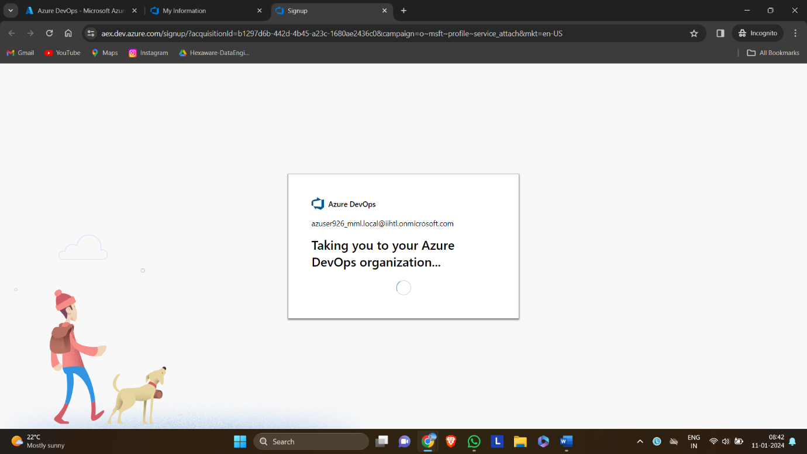

Creating a project

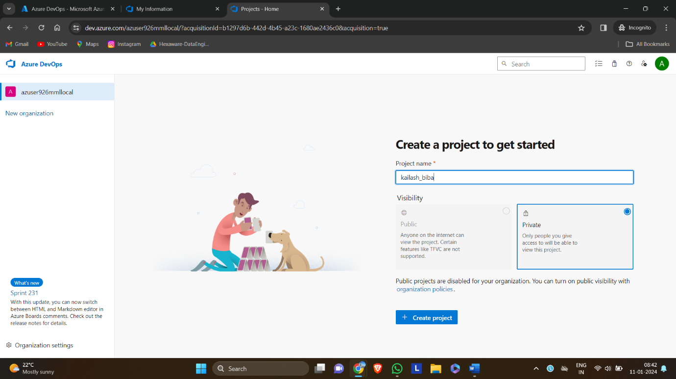

Select pipelines and select create pipeline

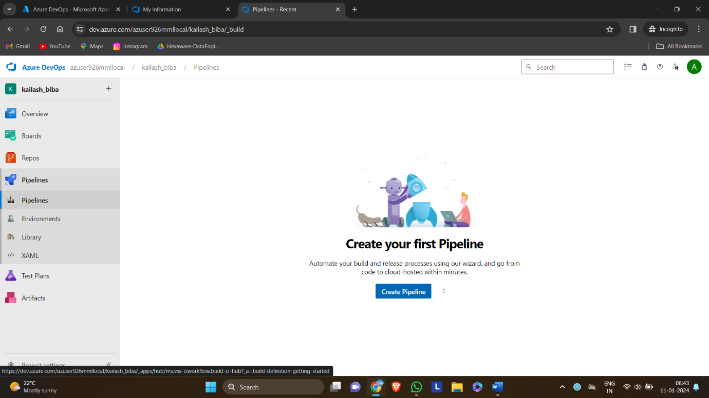

Select azure git repos

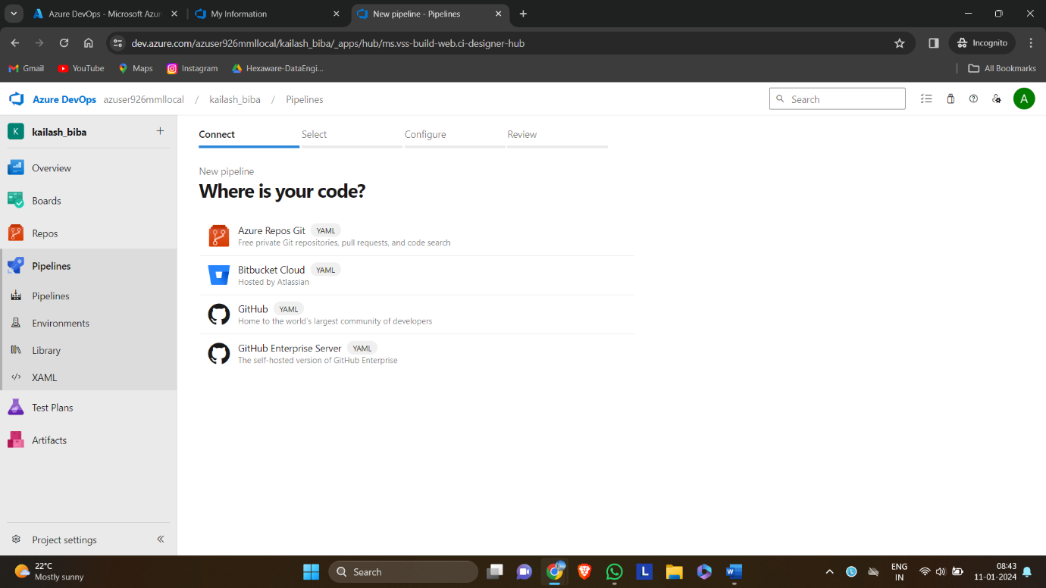

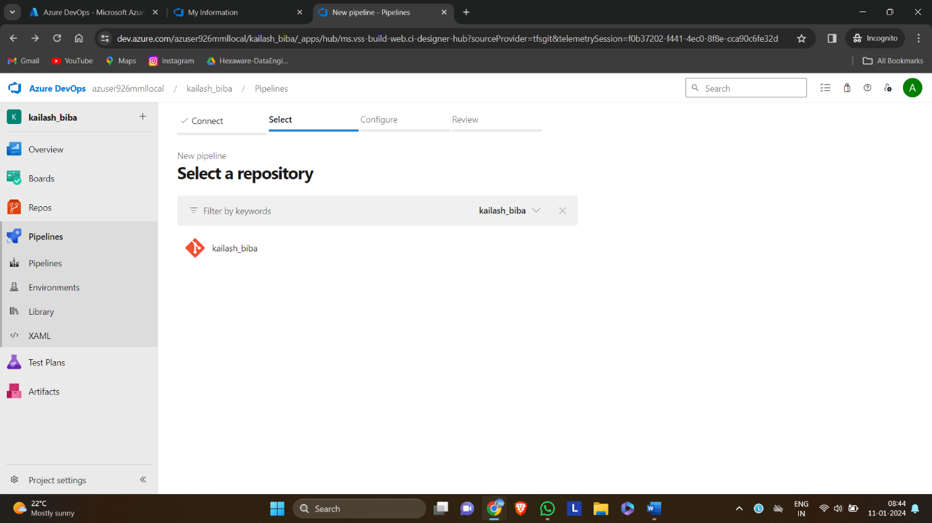

Select starter pipeline

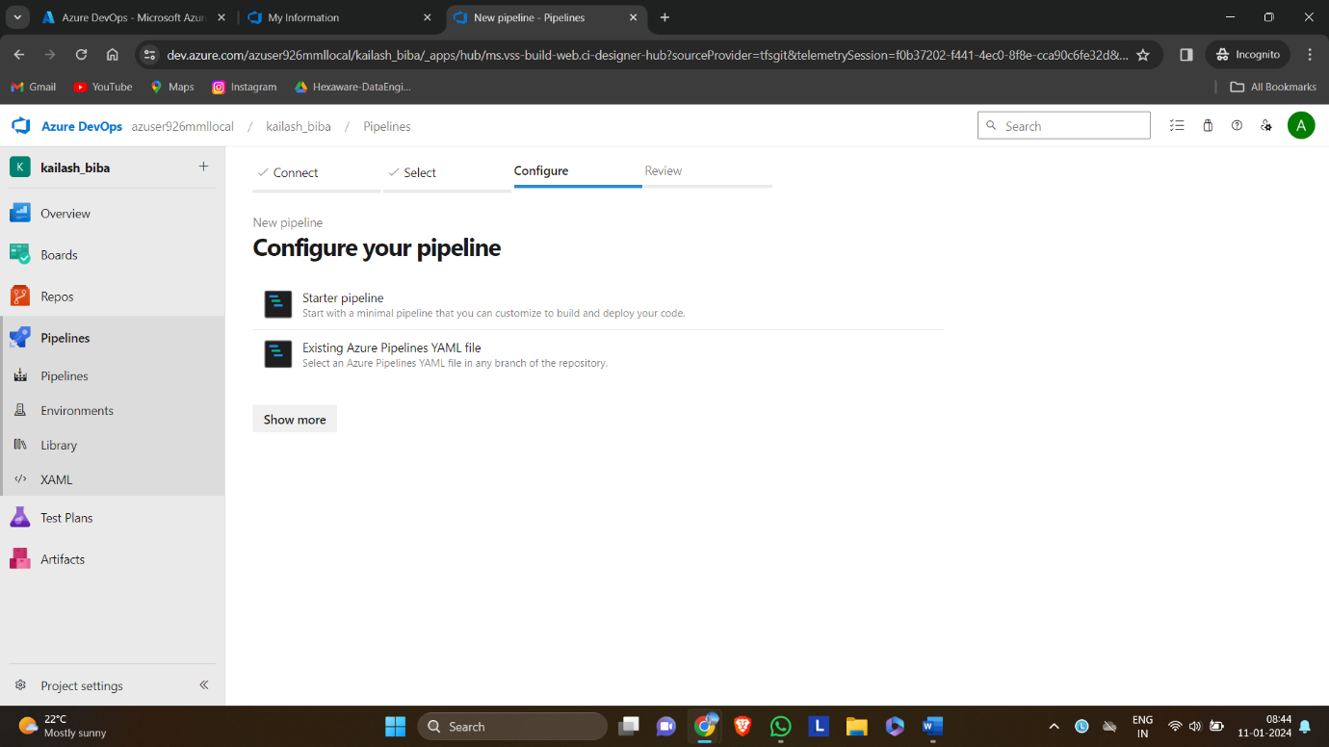

Review the code and select save and run

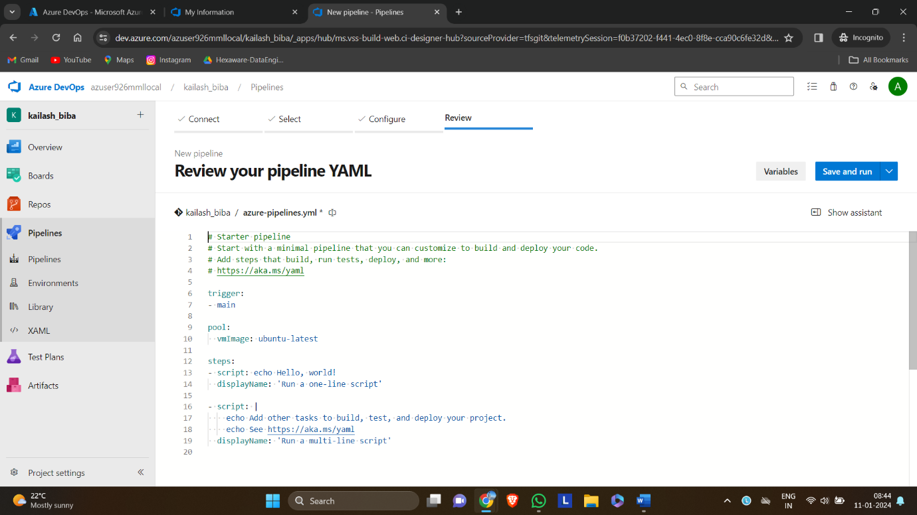

Give a commit message and run

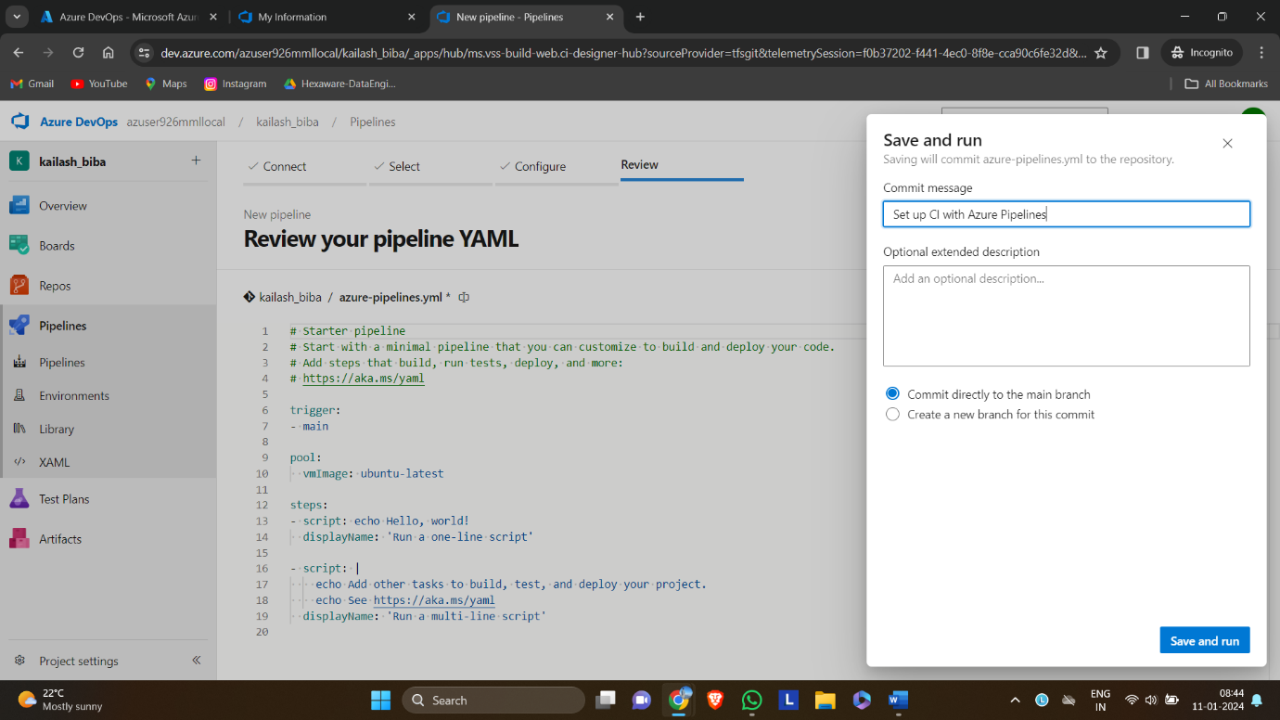

This is the azure pipeline.

